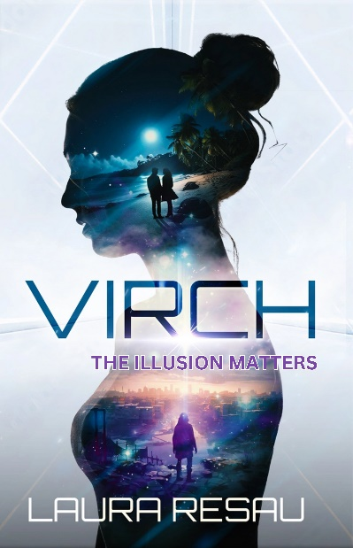
Book Club Guide

VIRCH

by Laura Resau

Note that some questions contain spoilers!

- Liv finds messages from her loved ones back home: the driftwood message from her dad saying “do your best, that’s enough” and the scraps of fabric embroidered with fly, love, breathe, live. Describe her relationship with her family and mentor, Delfina. How do these messages help her in her missions on the island?

- What meaning does the heron have for Liv? How do her heron sightings affect her? Do you have a special animal that has held significance for you or reminds you of a loved one?

- How did you feel about Liv and Wolf’s relationship? Their love develops over the course of less than two days, drastically transforming from their early interactions. What caused these close feelings to form so fast? Can you relate to having intense feelings developing quickly because of circumstances?

- How do Liv and Wolf help each other grow and find strength? Have you had any experiences where someone brought out the best in you and made you feel stronger?

- How did your feelings about Spiro change throughout the story? Did you have empathy for him? How did you feel about his relationship with Kiri?

- How did you feel about Casper? What were his motivations for his actions? Can you think of any famous people in our society who have things in common with Casper? You might think of his position of power and wealth, his big-thinking and innovation, his personality traits, his values, etc.

- Liv feels intense guilt about feeding oysters to her sister. Can you relate to accidentally doing something that caused someone harm? What helps her release that shame and how do her feelings about herself change when she does? Who or what do you feel is to blame for her sister’s illness?

- What are some of the big ideas about human and environmental rights that come up in the book? Do you see any parallels in our lives?

- How did you feel about Liv and Wolf’s decision at the end of their lives in the original world? Would you have done the same?

10. How did you feel about their decision to keep the nature of their reality secret at the end of the book? What would you have done?

11. What did you think about the section from the point of view of the whale? How would a world without humans feel to animals? How would it affect the environment?

12. What were your main emotions and thoughts throughout the book? How did they shift with different events and revelations? By the end of the book, how were your seeing your own life differently? What new questions did you ask about your own existence?

13. What was your favorite element of the novel? Least favorite?

14. What did you think about the technology and science in the story? Do you think our society is heading in that direction? Why or why not? Do you think it’s exciting or terrifying to imagine this?

15. This novel has elements of thriller, sci-fi, love story, and social commentary. Can you think of any other books or movies that have similarities? How is Virch similar and different from them?

Ideas for a Virch-themed book party

Playlist

Don’t Dream it’s Over by Crowded House
Kiss Me by Sixpence None the Richer
Yoshimi Battles the Pink Robots by The Flaming Lips
I’ll be Your Mirror by The Velvet Underground
What a Wonderful World by Louis Armstrong
La Vie en Rose by Edith Piaf
Dream a Little Dream cover by Ella Fitzgerald
Beethoven 7th Symphony 2nd Movement with Marco Beltrami
Somewhere Only We Know cover by Renee Dominique
I’ll Stop the World and Melt with You by Modern English
Air Between Us by Hele

Fun Extras

Food~ Peach cobbler. Fresh strawberries. Jasmine tea.

Décor~ Beachy with tropical flowers and plants

Party Favors~ shells and small potted succulents

About the Author

Laura Resau is the award-winning author of ten highly acclaimed young adult and children’s books, including Red Glass, The Indigo Notebook, and The Queen of Water (co-authored with María Virginia Farinango). Loved by readers of all ages, her books have garnered many starred reviews and honors, including the International Reading Association’s YA Fiction Award, the Américas Award, five Colorado Book Awards, and spots on “best-of” book lists from Oprah, School Library Journal, the American Library Association, Bank Street, and more.
You might find Laura writing stories in a vintage trailer in her backyard in Fort Collins, Colorado or in her tiny cabin in the Rocky Mountains or on her travels in Latin America and Europe. She loves wandering in the forest with her husband, cuddling with her husky pup, and head-banging (very carefully) at her teenage son’s rock shows.

Read more about Laura and her books at www.LauraResau.com.

