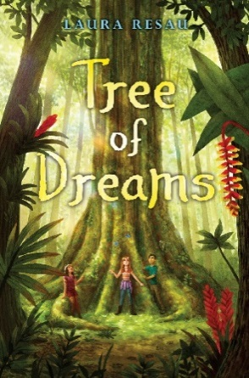
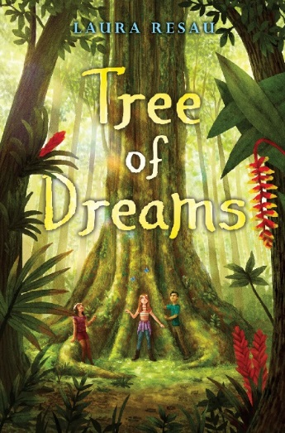
Tree of Dreams
From the Américas Book Award Winner
LAURA RESAU

Chocolatey Book Club Party!

Yay! You’ve chosen Tree of Dreams as your book club read! This guide will give you ideas on what to serve, how to decorate, what to wear, what to listen to, what to discuss, what to do for fun, and how to get free, signed bookmarks.
To Serve
- Hot chocolate with interesting spices and flavors, topped with whipped cream. You could make this iced if the weather’s warm. (You might make this together as a fun group activity—see below for instructions!)
- Sliced tropical fruits like papaya, mango, pineapple, etc. Or, you could make “agua de papaya” or another natural fruit drink by blending it in a blender with water and sugar.
- Truffles of different flavors
- Chocolate taster flight (see instructions on p. 3!)

To Wear
- Dress up like a character. For example:
  - Maybe in your favorite, comfy old clothes like Coco does.
  - Or in vintage dresses and elaborate braids like her mom.
  - Or in a cool vintage T-shirt like Isa’s.
  - Or in sleek black yoga clothes like Nieves.
  - Or in old-fashioned traveler’s or explorer’s clothes like Gali.
  - Or as the jaguar! Or the ceiba tree!
To Decorate
- Hearts everywhere— even better if you can find anatomically correct human hearts!
- Stars and star flowers hung from the ceiling.
- Small, potted tropical plants that members can bring home as party favors or door prizes. (You can find photos of what that plant looks like in its natural rainforest setting.)
To Listen To
- Rain forest sound recordings, of course! (You can find these online on YouTube or at the library).
To Do for Fun
- Concoct hot chocolate
  - Put containers of ground cacao/cocoa, sugar (or honey or agave), natural flavorings (vanilla, almond extract), edible flowers (rose, lavender, violet), spices (cinnamon, cardamom, chile, clove, allspice, ginger, etc), dried lemon or orange zest), and other creative ingredients on the kitchen counter.
  - With adult supervision, heat up dairy milk, coconut milk, almond milk, and/or soy milk gently on the stove.
  - Members pour warm milk into their mugs, and add whatever flavorings they’d like.
  - Stir it up with a little whisk or molinillo and top with whipped cream!

- Chocolate tasting
  - Get several bars of high-quality chocolate, in different flavors or from different countries. Number the packaging of each one.
  - Break each one into pieces and put each broken-up bar on a plate with the corresponding number.
  - Sample each one, moving it around in your mouth as Coco instructs in the book.
  - Discuss the flavors, using a “chocolate flavor wheel” (easy to find online) to give you words to describe the taste.
  - Between samples, cleanse your palate with water crackers (or bread) and lukewarm water.
  - Afterward, talk about your favorite chocolate sample.
  - To find delicious creative writing activities for a literary chocolate tasting, please go to http://www.lauraresau.com/wild-chocolate .

- Bond with a tree
  - If the weather’s nice and there’s a natural area nearby, sit beneath a tree, touch her bark, and imagine a conversation with her.
  - What would she tell you? Jot down what she “says”… maybe it will end up as a poem!
  - Share your tree conversation/poem with others in your group.

- Videos
  - Watch a 4-minute video by the non-profit group Amazon Watch about how indigenous Ecuadorians (from the Quichua culture) are trying to protect their land from oil drilling. https://www.youtube.com/watch?v=_sRDxXWkCnM
  - For links to more short videos, including a musical slideshow from Laura’s Amazon research trip, please go to http://www.lauraresau.com/wild-chocolate .

- Heart craft
  - Find an anatomical heart line drawing and print out enough copies for everyone in your group. (Find this at the end of this packet or free online: http://worldartsme.com/anatomical-heart-diagram-clipart.html.)
  - Color the heart with your favorite colors and write what things, people, places, and animals have a special place in your heart.

- Jewelry-making
  - String necklaces, bracelets, and anklets.
  - You can use tree nut beads and heart milagros, which are available at reasonable prices from etsy.com. Make sure to order them well in advance.

- Tree craft
  - Draw a tree with big roots. In the roots, write things, people, places, and animals you care about that aren’t part of your daily life. These could be things across the world that you feel in some way connected with through books, movies, or the news.

- Cacao Guess Who?
  - Re-read aloud some of Coco’s descriptions of people as if they were cacao.
  - Now, jot down a (kind-spirited!) description of someone in your life or your book club as if they were cacao.
  - See if other members can guess who you’re describing.

- Chocolate factory tour or shop visit
  - See if there’s a bean-to-bar chocolate business near you, and ask if you can hold your book club meeting there.
  - Here are two lists of craft chocolate factories/shops: http://www.chocolatenoise.com/chocolate-today/2017/9/19/my-top-50-bean-to-bar-chocolate-makers-in-the-united-states
  - https://medium.com/@CarolWiley/183-bean-to-bar-chocolate-makers-in-the-united-states-a7a31325733d

To Discuss
- How does Coco’s journey change how she sees herself, her loved ones, and the world? Have you ever taken a journey that changed you? Describe the journey and how it changed you.

- Trees—especially the ceiba tree in the Amazon and the cottonwood tree in Heartbeat Springs-- play important roles in the book. What are the kids’ special connection with these trees? Is there a tree in your life that you feel connected with? Describe her, and tell what you think her personality might be like.

- Many people, like the indigenous Huaorani, believe that animals, plants, stones, the earth and other parts of nature have their own form of consciousness. What do you think about this idea?

- For the first part of the book, Coco feels distant from her former best friend, Leo. Why? How does she deal with it? Have you ever had a friendship end? How did you feel? How did you deal with it?

- What environmental issues do the kids encounter in the book? How do they try to solve them? What environmental issues (near or far) concern you? What are possible solutions?

- How do hearts play a big role in the book? Early on, Coco talks about who and what have special places in her heart. By the end of the book, what else feels connected to her heart? How does she think of her heart by the end? How does Gali think about his heart, and how does this change by the end? How do you think of your own heart? Maybe you could come up your own metaphor!

- Chocolate is very important in the book. What new things did you learn about chocolate? Do you have a new perspective on chocolate now? How so? As Coco explains, chocolate is fermented cacao beans. Can you think of some other fermented foods that you eat? What are your favorites?

- Who was your favorite character? Describe that character and tell what you loved about them.

- Imagine a sequel to this book. What would happen? What would the setting be? The plot? The new challenges? Which character(s) would it focus on?

How to Get Bookmarks
- Want Laura to send you up to 30 free, autographed bookmarks for your book club? Just email Laura at Lauraresau@gmail.com with the subject heading “Tree of Dreams Book Club,” tell a bit about your book club, and give your mailing address!

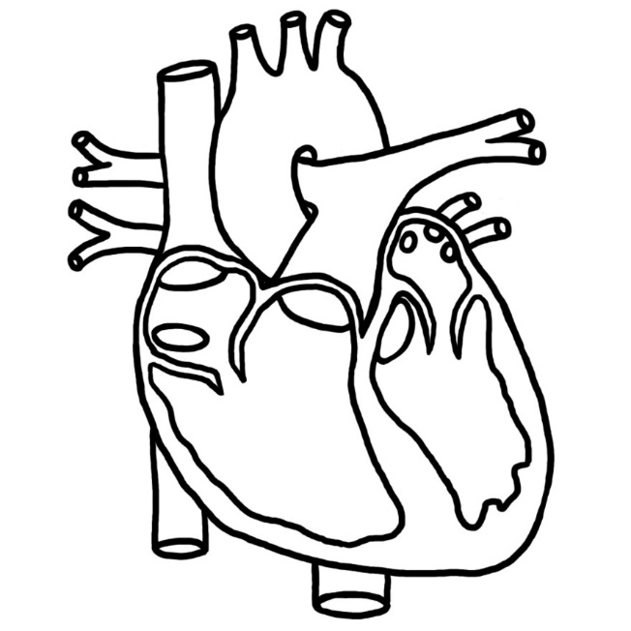

Free heart image from http://worldartsme.com/anatomical-heart-diagram-clipart.html

