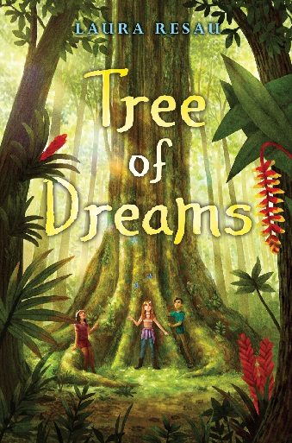
Tree of Dreams
From the Américas Book Award Winner
LAURA RESAU

Grow Your Heart Educator Resources
with Common Core and STEM connections

About the Book

“A moving exploration of friendship, activism, and how chocolate
makes everything better.” –Kirkus Reviews, STARRED

Coco loves chocolate. When she’s not helping run her mom’s chocolate shop, El Corazón, she’s tinkering with recipes, devising unique and delicious treats to entice chocolate lovers.
But amid this sweetness, a few things are troubling Coco. Her best friend, Leo, isn’t talking to her and El Corazón is on the verge of going out of business.
Soon Coco starts dreaming about a wise and wondrous ceiba tree that promises her answers. And when she and Leo get the opportunity to journey from their Colorado home to the Amazon Rain Forest, Coco has faith she’ll find a way to save El Corazón.
But when she arrives, Coco comes face-to-face with the environmental and cultural harm done to the rain forest and to the Huaorani people who call it home. As friendships bloom, she feels her heart growing and caring about people, places, and trees far outside her own world.
In this urgent, beautiful novel, acclaimed author Laura Resau shows us that by working together —and with a little magic — hope can be restored, root and branch. Ages 9 to 14, grades 4-8, Scholastic Press.

“And if this heart can expand so much, clear across the world, then maybe, just maybe there’s a human out there whose heart will do the same.” ~ The Ceiba Tree

About the *Grow Your Heart* Experience

Tree of Dreams by Laura Resau is the magical tale of a girl whose heart grows big enough to embrace the struggles, hopes, and dreams of kids in a rain forest community far from her home. Together, they all work to reach their goals. You can help young people take the compassionate and empowering ideas in Tree of Dreams to heart by becoming a “Grow Your Heart” classroom or library.

- Read, talk, and write about Tree of Dreams with this guide.
- Create a heart wall in your classroom. Each student gets an anatomical heart cut-out. On the heart, students write four people/places/things they care about. Over the school year, as they learn about the world, they’ll add new people/places/things they care about to their hearts… and watch their hearts grow.
- Download and print a free Grow Your Heart poster for your classroom from www.LauraResau.com/wild-chocolate .
- Sign up for the newsletter at www.LauraResau.com for updates.
- Use the hashtag #growyourheart on social media to show how students’ hearts are growing and connecting with others.
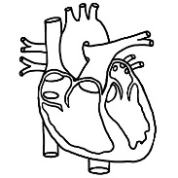
See p. 8 for free heart image or http://worldartsme.com/anatomical-heart-diagram-clipart.html

Before You Read

- Look at the book cover, read the summary, and spend a moment flipping through the book. What role do you think the tree might play in this story? Discuss books or movies in which a tree played an important role.

- Is there a tree that is special to you? Describe it, and imagine what its personality might be like. Imagine what the personality of the tree in the book might be.

- What do you know about the Amazon Rain Forest? What kinds of plants, animals, and people live there? What challenges have the rain forest and its inhabitants faced in recent years?

- From the summary, you know that the main character will take a life-changing journey. Have you taken a journey or trip that changed you somehow? Explain how you changed, and what sparked that change.

“I feel my heart wending with the roots of the cottonwood and ceiba, with the threads of Leo’s heart, with all my friends’ and family’s. I think of the universe and every atom in it and I know that whatever happens, my heart can grow to embrace it all.” ~Coco
Talking and Writing
(Please see end of packet for specific core curriculum standards met by each question.)

1) Contrast the voice of the ceiba tree (p. 19 and throughout) with Coco’s voice. (Here, “voice” refers to the thoughts, speech patterns, and style of the narrator.) How does the author use sentence pattern, word choice, repetition, figurative language, and other techniques to make these two voices distinct? How do their unique ways of expressing themselves show their points of view?

2) Coco uses the figurative language of the heart to describe her feelings about what she loves most in life (pgs. 3-10 and throughout). Discuss how her details about parts of the heart (left atrium, right atrium, left ventricle, right ventricle), and blood flow (p. 47) help you imagine her emotions.

3) In the first eighty pages of the book, how does Coco feel about Leo? Re-read her conversation about him with Gali on the plane (p. 72 to end of section on p. 73). What does she say explicitly and what can you infer? What figurative language does Coco use to discuss her feelings about Leo?

4) How does Coco see the world in terms of chocolate? How does she understand the changes happening in people in terms of the chocolate–making process? Summarize these changes, then give details from the book to support your claims.

5) Give an example of a science metaphor or simile Coco uses and explain what she means. How does this figurative language express her personality? How does this figurative language affect the tone (attitude/feelings) in her narration?

6) Coco mentions that “theobromine” is a chemical in chocolate (pgs. 10, 68, 156, and more). How can you break apart the word “theobromine” to understand the word origin? Look up the Greek roots online for a clue. How does this relate to historical information Coco gives us about chocolate (p. 102)?

7) After Coco witnesses the destruction from the oil drilling with her friends, she goes to the waterfall for a spiritual cleaning ritual (p. 182-206). Describe the contrast between the waterfall setting and the oil field setting. How do her thoughts and feelings change? At first, why did she come to the Amazon? Now what is her new mission?

8) Listen to excerpts of the audiobook from the ceiba’s and Coco’s sections. Notice details like voice pitch, pronunciation, pauses, intonation, and emotion. Does this fit with how you imagined their voices in your head as you read? What was similar and different?

9) Read poems about the forest, like “Lost In The Forest” by Pablo Neruda, South American Poet, or “Sleeping In The Forest” by Mary Oliver, American poet (both available online). How do you think each poet feels about the forest? Give examples of the figurative language and descriptions to support your claim. What are similarities and differences among Tree of Dreams and the poem(s) you read, as far as how the narrators feel about the forest?

10) Coco uses many scientific words when describing chocolate’s effect on our brains and bodies (p. 10, 16, 68, 77, 156, 185) . Choose three of these unfamiliar words and try to figure out their meaning and part of speech through context and language roots. Guess how you’d pronounce the words. Afterward, look up the pronunciation and meaning of the unfamiliar words to see if you were right.

11) How does Gali feel about his past mistakes? How does he find redemption (forgiveness) for them by the end? Give clear, organized evidence to support your ideas.

12) Describe Coco’s character arc over the course of the book. In particular, how does Coco see her heart at the beginning of the book? By the end? What events or interactions spark her heart to change along the way?

13) Imagine what might happen in a sequel to this book. Brainstorm, plan, and finally, write the first chapter of a sequel—for example, maybe scenes of Coco returning to the Amazon. Use dialogue, pacing, and description to develop the characters and their experiences. You should have several scenes in the chapter, separated by space breaks, as the author does. Be sure to use all your senses, as well as figurative language. Later, revise and edit your chapter with feedback from your peers and teacher. Publish the first chapter of the sequel on your school’s online platform, and share with others. Compare and contrast the events of your first chapter with your classmates in a fun online discussion.

Expanding Your World

(Please see end of packet for specific core curriculum standards met by each question.)

1) In the Author’s Note, Laura Resau gives personal and scientific evidence that the Amazon rain forest is endangered. Do your own research on the threats to the Amazon’s environment and cultures. Do you agree that it is in danger and needs to be protected? Why? What are challenges to protecting it and possible solutions? Give evidence from credible sources to support your claims. Revise and edit with feedback from peers and your teacher.

2) Research the process of bean-to-bar chocolate making. Write a newspaper or magazine article about the process, using a formal style with facts, examples, definitions, transition words, accurate vocabulary, and concrete details. Use graphics (like maps and charts) and organized formatting to help readers understand.

3) Choose a STEM-related (science, technology, engineering, mathematics) research topic to investigate. Use several credible print and digital sources that you cite. You may quote and paraphrase information, but be careful not to plagiarize. Present the topic to your class. Here are some ideas:
- Neurological (brain-related) effects of chocolate on mood and emotion.
- The process of fermentation in foods like cheese, chocolate, yogurt, kombucha, sourdough bread, etc.
- How scientists estimate the number of stars in our galaxy and the universe,
- Spiral patterns in nature (from DNA to plants to the Milky Way)
- Negative effects of deforestation on cultures, the environment, and global climate change
- Sustainable economic projects in rain forests
- Interdependence of organisms in an ecosystem, especially symbiotic relationships
- The extinction of species and discovery of new species
- How trees communicate and help each other
- Indigenous groups of the Amazon—their traditional lifestyles, changes in their lives in recent decades, and how they’re working to protect their land and culture. (You could pick one group or include several.)

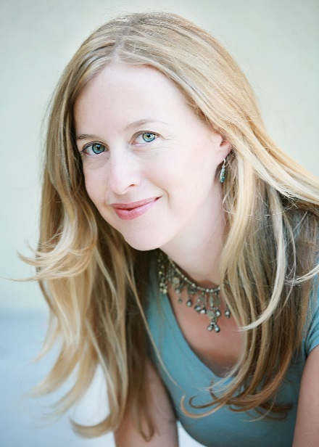
About the Author

Laura Resau is the award-winning author of The Lightning Queen (Scholastic) and eight other highly acclaimed young adult and children's novels. Set in Latin America and Europe, her books are inspired by her time abroad as a cultural anthropologist, ESL teacher, student, and adventurous writer. She loves sitting under trees, wandering by rivers, camping in the mountains, playing ukulele, biking around town, and eating chocolate. She lives with her husband, son, and beagle in Fort Collins, Colorado.

Resources

These materials were prepared by Laura Resau, former ESL teacher, and reviewed by her mother, Chris Resau, retired K-8 educator. Please visit http://www.LauraResau.com/wild-chocolate for a Book Party Guide, a Literary Chocolate Tasting Guide, photos of Laura’s research in the Amazon and a chocolate shop/factory, links to information on indigenous rights and conservation issues and non-profits, a poster download, and more.

Connect
- Sign up for Laura’s newsletter for updates and giveaways at www.LauraResau.com .
- Connect through social media (Instagram, Facebook, Twitter, Goodreads) for updates and giveaways. (@LauraResau)
- Email Laura to see if she’s available for a free, 20-minute Skype visit q&a (Lauraresau@gmail.com , subject “Skype with Class”)
- Tell how your students have connected with the story and how their own hearts have grown! Email Laura or tag her on social media, and use the hashtag #treeofdreams and #growyourheart.
- Email Laura to get an address where you can send student letters.
- Connect with indigenous/conservation organizations to make a difference!

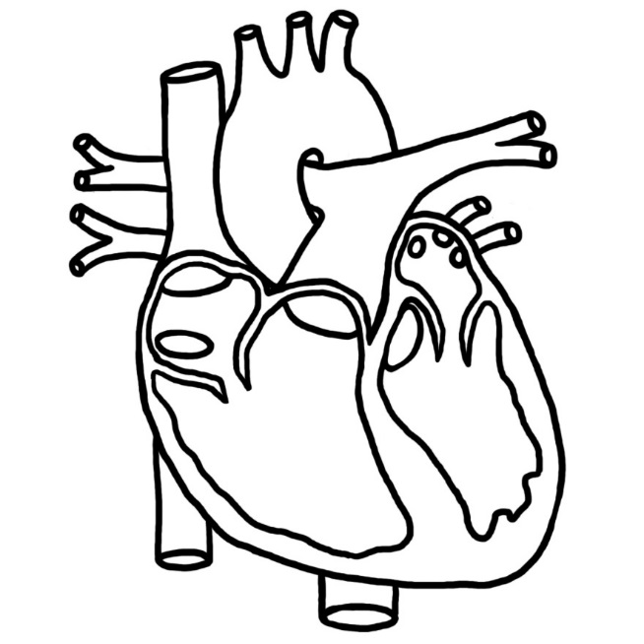

Free heart image from http://worldartsme.com/anatomical-heart-diagram-clipart.html

Core Curriculum Standards Met
for Talking and Writing questions 1-13

1) CCSS.ELA-Literacy.RL.6.6
Explain how an author develops the point of view of the narrator or speaker in a text.
CCSS.ELA-Literacy.L.6.3
Use knowledge of language and its conventions when writing, speaking, reading, or listening.
CCSS.ELA-Literacy.L.6.3.a
Vary sentence patterns for meaning, reader/listener interest, and style.*
CCSS.ELA-Literacy.L.6.3.b
Maintain consistency in style and tone.*

2) CCSS.ELA-Literacy.L.6.5.b
Use the relationship between particular words (e.g., cause/effect, part/whole, item/category) to better understand each of the words.
CCSS.ELA-Literacy.RL.6.4
Determine the meaning of words and phrases as they are used in a text, including figurative and connotative meanings; analyze the impact of a specific word choice on meaning and tone.

3) CCSS.ELA-Literacy.RL.6.1
Cite textual evidence to support analysis of what the text says explicitly as well as inferences drawn from the text.
CCSS.ELA-Literacy.L.6.5
Demonstrate understanding of figurative language, word relationships, and nuances in word meanings.
CCSS.ELA-Literacy.L.6.5.a
Interpret figures of speech (e.g., personification) in context.

4) CCSS.ELA-Literacy.RL.6.2
Determine a theme or central idea of a text and how it is conveyed through particular details; provide a summary of the text distinct from personal opinions or judgments.

5) CCSS.ELA-Literacy.RL.6.4
Determine the meaning of words and phrases as they are used in a text, including figurative and connotative meanings; analyze the impact of a specific word choice on meaning and tone

6) CCSS.ELA-Literacy.L.6.4.b
Use common, grade-appropriate Greek or Latin affixes and roots as clues to the meaning of a word (e.g., audience, auditory, audible).

7) CCSS.ELA-Literacy.RL.6.5
Analyze how a particular sentence, chapter, scene, or stanza fits into the overall structure of a text and contributes to the development of the theme, setting, or plot.

8) CCSS.ELA-Literacy.RL.6.7
Compare and contrast the experience of reading a story, drama, or poem to listening to or viewing an audio, video, or live version of the text, including contrasting what they "see" and "hear" when reading the text to what they perceive when they listen or watch.

9) CCSS.ELA-Literacy.RL.6.9
Compare and contrast texts in different forms or genres (e.g., stories and poems; historical novels and fantasy stories) in terms of their approaches to similar themes and topics.
CCSS.ELA-Literacy.W.6.9.a
Apply grade 6 Reading standards to literature (e.g., "Compare and contrast texts in different forms or genres [e.g., stories and poems; historical novels and fantasy stories] in terms of their approaches to similar themes and topics").

10) CCSS.ELA-Literacy.L.6.4.c
Consult reference materials (e.g., dictionaries, glossaries, thesauruses), both print and digital, to find the pronunciation of a word or determine or clarify its precise meaning or its part of speech.
CCSS.ELA-Literacy.L.6.4
Determine or clarify the meaning of unknown and multiple-meaning words and phrases based on grade 6 reading and content, choosing flexibly from a range of strategies.
CCSS.ELA-Literacy.L.6.6
Acquire and use accurately grade-appropriate general academic and domain-specific words and phrases; gather vocabulary knowledge when considering a word or phrase important to comprehension or expression.
CCSS.ELA-Literacy.L.6.4.a
Use context (e.g., the overall meaning of a sentence or paragraph; a word's position or function in a sentence) as a clue to the meaning of a word or phrase.
CCSS.ELA-Literacy.L.6.4.d
Verify the preliminary determination of the meaning of a word or phrase (e.g., by checking the inferred meaning in context or in a dictionary).

11) CCSS.ELA-Literacy.W.6.1.a
Introduce claim(s) and organize the reasons and evidence clearly.
CCSS.ELA-Literacy.W.6.1
Write arguments to support claims with clear reasons and relevant evidence.

12) CCSS.ELA-Literacy.RL.6.3
Describe how a particular story's or drama's plot unfolds in a series of episodes as well as how the characters respond or change as the plot moves toward a resolution.

13) CCSS.ELA-Literacy.W.6.4
Produce clear and coherent writing in which the development, organization, and style are appropriate to task, purpose, and audience. (Grade-specific expectations for writing types are defined in standards 1-3 above.)
CCSS.ELA-Literacy.W.6.5
With some guidance and support from peers and adults, develop and strengthen writing as needed by planning, revising, editing, rewriting, or trying a new approach. (Editing for conventions should demonstrate command of Language standards 1-3 up to and including grade 6 here.)
CCSS.ELA-Literacy.W.6.6
Use technology, including the Internet, to produce and publish writing as well as to interact and collaborate with others; demonstrate sufficient command of keyboarding skills to type a minimum of three pages in a single sitting.
CCSS.ELA-Literacy.W.6.3.b
Use narrative techniques, such as dialogue, pacing, and description, to develop experiences, events, and/or characters.
CCSS.ELA-Literacy.W.6.3.c
Use a variety of transition words, phrases, and clauses to convey sequence and signal shifts from one time frame or setting to another.
CCSS.ELA-Literacy.W.6.3.d
Use precise words and phrases, relevant descriptive details, and sensory language to convey experiences and events.
CCSS.ELA-Literacy.W.6.3.e
Provide a conclusion that follows from the narrated experiences or events.

Core Curriculum Standards Met
for Expanding Your World Questions 1-3
1) CCSS.ELA-Literacy.W.6.1.b
Support claim(s) with clear reasons and relevant evidence, using credible sources and demonstrating an understanding of the topic or text.
CCSS.ELA-Literacy.W.6.1.c
Use words, phrases, and clauses to clarify the relationships among claim(s) and reasons.
CCSS.ELA-Literacy.W.6.1.d
Establish and maintain a formal style.
CCSS.ELA-Literacy.W.6.1.e
Provide a concluding statement or section that follows from the argument presented.
CCSS.ELA-Literacy.W.6.2
Write informative/explanatory texts to examine a topic and convey ideas, concepts, and information through the selection, organization, and analysis of relevant content.
CCSS.ELA-Literacy.W.6.10
Write routinely over extended time frames (time for research, reflection, and revision) and shorter time frames (a single sitting or a day or two) for a range of discipline-specific tasks, purposes, and audiences.

2) CCSS.ELA-Literacy.W.6.2.a
Introduce a topic; organize ideas, concepts, and information, using strategies such as definition, classification, comparison/contrast, and cause/effect; include formatting (e.g., headings), graphics (e.g., charts, tables), and multimedia when useful to aiding comprehension.
CCSS.ELA-Literacy.W.6.2.b
Develop the topic with relevant facts, definitions, concrete details, quotations, or other information and examples.
CCSS.ELA-Literacy.W.6.2.c
Use appropriate transitions to clarify the relationships among ideas and concepts.
CCSS.ELA-Literacy.W.6.2.d
Use precise language and domain-specific vocabulary to inform about or explain the topic.
CCSS.ELA-Literacy.W.6.2.e
Establish and maintain a formal style.
CCSS.ELA-Literacy.W.6.2.f
Provide a concluding statement or section that follows from the information or explanation presented.
CCSS.ELA-Literacy.W.6.3
Write narratives to develop real or imagined experiences or events using effective technique, relevant descriptive details, and well-structured event sequences.
CCSS.ELA-Literacy.W.6.3.a
Engage and orient the reader by establishing a context and introducing a narrator and/or characters; organize an event sequence that unfolds naturally and logically.

3) CCSS.ELA-Literacy.W.6.7
Conduct short research projects to answer a question, drawing on several sources and refocusing the inquiry when appropriate.
CCSS.ELA-Literacy.W.6.8
Gather relevant information from multiple print and digital sources; assess the credibility of each source; and quote or paraphrase the data and conclusions of others while avoiding plagiarism and providing basic bibliographic information for sources.
CCSS.ELA-Literacy.W.6.9
Draw evidence from literary or informational texts to support analysis, reflection, and research.

